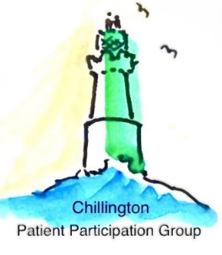
Patient Participation Group

Dementia Action Week  19 -25 May  Raising awareness of Dementia with a focus on early diagnosis  As part of Dementia Action week, PPG members created an information board and spent time in the surgery signposting people to Dementia support.  Early diagnosis is vital to give people access to the care, treatment and support they need. Yet, 1 in 3 people with dementia do not have a diagnosis. If you’re worried about yourself, or someone close to you, contact The Alzheimer's Society for help  Alzheimer's Society  or call 0333 150 3456 | 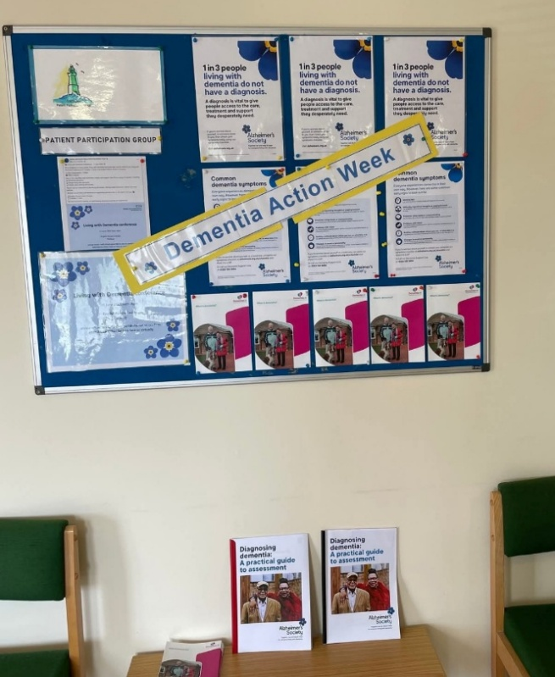  Chillington Health Centre

Living with Dementia Conference  11 June 2025  FREE to attend  Hear from a range of speakers including  Dementia specialists  People living with dementia  Family carers sharing their stories.  There will also be information stalls, offering helpful resources, advice, and local services.  Whether you’re living with dementia or supporting someone who is, this event is for you. | 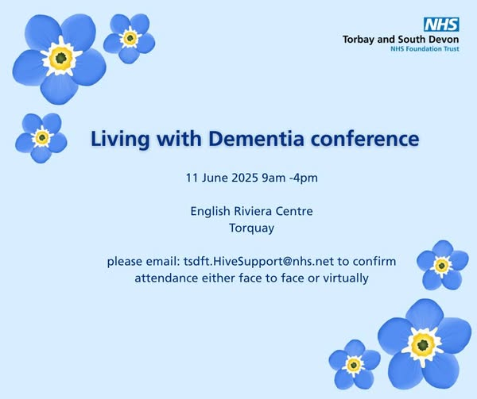

Type 2 Diabetes Prevention Week  26 May – 1 June  An estimated 6.3 million people in the UK live with prediabetes, but many are unaware. Without support to reduce this risk, they may go on to develop type 2 diabetes, which can cause many health complications.  Diabetes UK is raising awareness this week of the different risk factors you may not be aware of and how people can reduce their risk.  The NHS has set up prevention programmes in all nations of the UK to support people at risk of developing type 2 diabetes; you can find out more from  Diabetes UK - Know diabetes. Fight diabetes. | Diabetes UK | 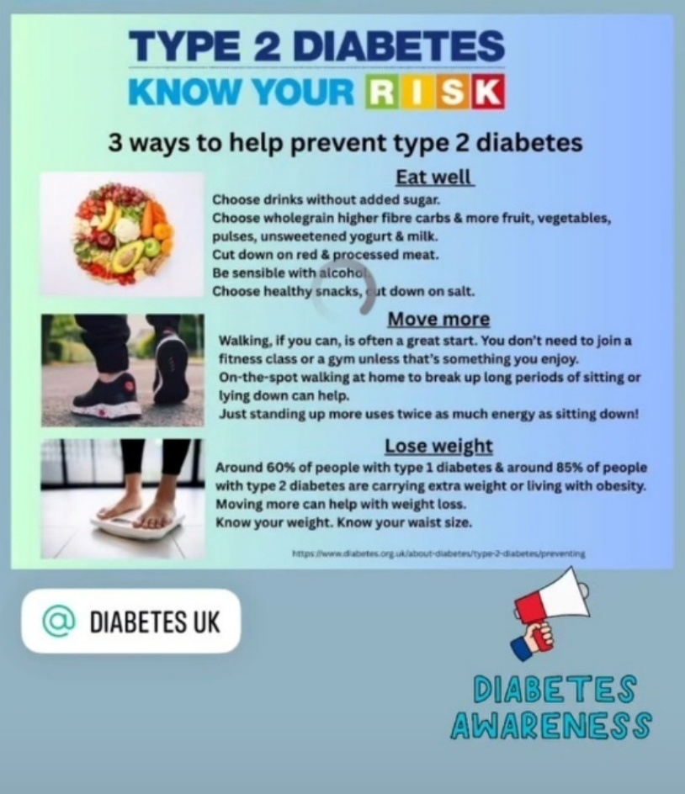
Put Nature into Your Health Plan
In the South Hams we are blessed with green spaces; nature is all around us. There are blue spaces too (rivers and sea) which many people enjoy all year round through a range of water-based sports and activities.
As the temperature starts to rise and the days lengthen, summer gives us the chance to spend an increasing amount of time out of doors connecting with nature and enjoying its wonders.
Over the last decade or so the health benefits of contact with nature have received increasing attention and have been widely researched. There is evidence that contact with nature improves people’s mental and physical health thus reducing the burden on the health system (Natural England 2025).
Regular contact with the natural environment has many benefits including:
- Reduction in stress
- Lowering blood pressure
- Increase in physical activity
- Stronger communities through greater social interaction
- An increase in awareness of the value of the natural environment
- Enhanced mood and energy levels
- Better sleep patterns
- Vitamin D production (for bone health, calcium absorption, and immune function)

Top Tip
Remember that the sun during the summer months has greater Ultraviolet (UV) intensity and can be a cause of skin cancer. The NHS recommends:
- Spending time in the shade between 11am and 3pm
- Never burning
- Covering up with suitable clothing and sunglasses
- Taking extra care with children
- Using at least factor 30 sunscreen
To find out more use the following link Sunscreen and sun safety - NHS

If you are interested in joining our PPG, please email chillingtonhealthcentreppg@outlook.com or call Kim Greening on 07942 289114

Published by Chillington Patient Participation Group. Editor: Andie Day

