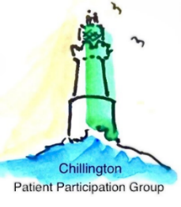
Patient Participation Group News

Patient Participation Group Awareness Week  This month, we celebrated Patient Participation Group Awareness Week by creating a poster board in the surgery to inform you about your PPG. We also conducted a survey to gather your experiences and views on the PPG and how we can develop it, to better serve you. Thank you to all who completed the survey; we will publish the results in our next newsletter. | 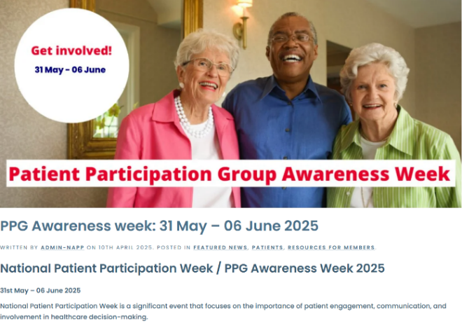
🫀 Update on Cardiac Services at Torbay Hospital  We’re pleased to share some positive news about local cardiac care, following concerns about the possible relocation of emergency procedures specifically out-of-hours pPCI (primary Percutaneous Coronary Intervention) from Torbay Hospital to Exeter.  ➡️ The proposal to move these emergency services has now been withdrawn.  This welcome decision is the result of determined campaigning by local residents, healthcare professionals, patients, and our MPs. A heartfelt thank you to everyone who spoke up to safeguard patient safety — your efforts really made a difference. | 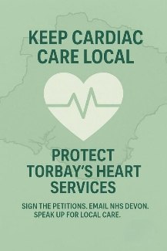  NHS Devon will now draw up a broader cardiology strategy, with their initial plans due in July.  🔗 You can read the latest updates directly from NHS Devon here: Cardiology - One Devon

🌸 Support for New Mums – MotherBorn Collective  Empowering mothers and families in and around Kingsbridge, South Devon with compassionate support, services and community  Becoming a parent is a joyful yet demanding time, and postnatal support is vital for a mother’s wellbeing and her baby’s healthy development. A key aspect of postnatal support is Social support—whether emotional, practical, or informational—can make all the difference.  MotherBorn Collective is a local, community-based group offering affordable, subsidised services designed to support new mums. These include:  🤱 Peer-to-peer breastfeeding support  - 💬 1:1 infant feeding advice  - 🧸 Equipment hire  - 📚 Informative workshops  - 🤸 Mum & Baby classes (yoga, massage, and more) | 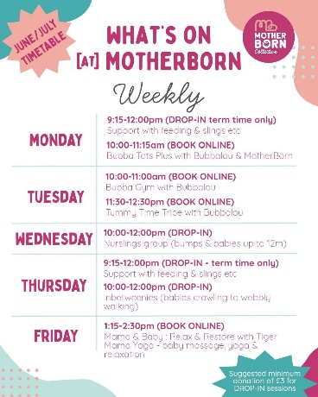  Further information can be found on the following links MotherBorn Collective CIC | Breastfeeding, Mum Support & Baby Groups | Kingsbridge, Devon  Nurslings @ MotherBorn - Breastfeeding & Mama Support Group | Facebook

This Month’s Top Tip
💧 Stay Hydrated – Feel Better Every Day! 💧
Drinking enough water is key to staying sharp, energised, and healthy. Research shows that proper hydration supports brain function, digestion and heart health. Even mild dehydration can cause fatigue, headaches, and poor concentration—and if you feel thirsty, your body’s already playing catch-up.
The NHS recommends 6–8 glasses of fluid daily—and it’s not just water that counts! Herbal teas and low-sugar drinks help too.
✅ Boosts brainpower ✅ Supports digestion & circulation ✅ Helps maintain energy throughout the day
Sip regularly—your body will thank you! 💙
Learn more about hydration & health: [NHS Guide](https://www.nhs.uk/live-well/eat-well/food-guidelines-and-food-labels/water-drinks-nutrition/)
Committee changes
We were sorry to say farewell to Sue Gay, who stepped down from the committee in April. We’re grateful for all her dedication during her time as secretary, especially for establishing the PPG Newsletter, which continues to be such a valuable part of our group.

📣 Get Involved

If you are interested in joining our PPG, please email chillingtonhealthcentreppg@outlook.com or call Kim Greening on 07942 289114

You can follow us on Facebook using the following link
Chillington Health Centre Patient Participation Group | Facebook
Or use the QR Code below



Published by Chillington Patient Participation Group. Editor: Andie Day

